**MADISON MEDICAL UNDERWRITING RECEIPT AUTO ALLOCATION APPLICATION**

**DESIGNED AND DEVELOPED BY**: JOSEPH MBUTHIA (Application/System Administrator Healthcare)

**PROGRAMMING LANGUAGE USED**: VB.NET

**LEGACY ALLOCATION PROCESS**

Medical underwriting team at Madison books new business, renewals and additions as part of their day to day task. This process culminates with a Premium debit being raised for the client. The client then pays the premium and a receipt is raised in SAP against the debit.

The underwriting team then pulls premium statement report which indicates clients who premiums have been raised against and one at a time they do manual allocation a repetitive process which takes them two to three days to complete. Receipt allocation has to been done in-time to allow processing of agent’s commission thus making it a crucial process which is done twice a month.

The underwriting team requested the process to be automated so as to increase their productivity and efficiency

**AUTO ALLOCATION APPLICATION**

Upon receipting at SAP, the particulars for the receipt i.e. receipt number and the amount is loaded back to HAIS. The auto allocation app queries for the receipt/receipts and automatically allocates against the debit as shown on the process flow below.

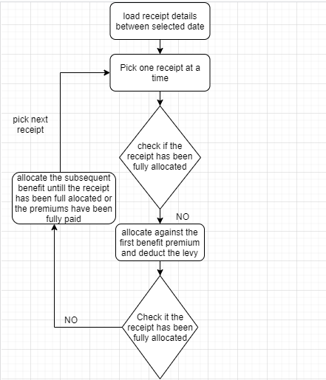

**MADISON MEDICAL UNDERWRITING RECEIPT AUTO ALLOCATION APPLICATION SIGNOFF**

Process owner Underwriting Manager General Manager

Application Administrator ICT Manager

Finance Managing Director